Module 5
Create table employee_details1 with columns of emp_id, emp_name, emp_salary and also employee_details2 with the same coulmns.

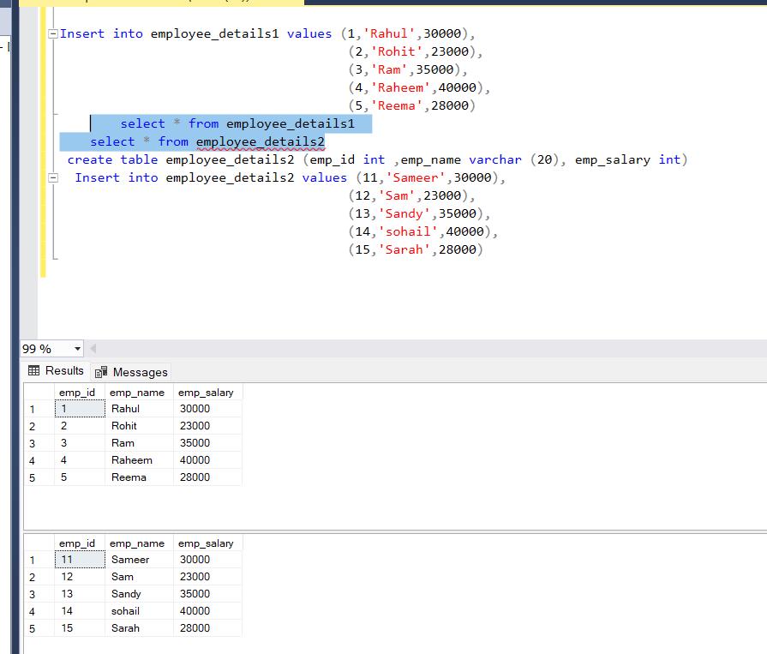

Module 5
Apply the union operator on the above tables:
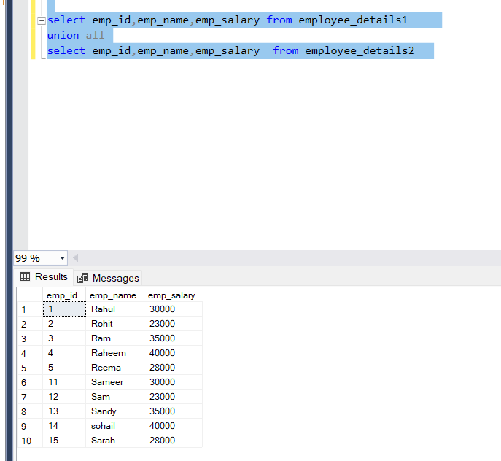

Module 3
Apply Intersect operator on the above tables

